Pizza Sales SQL Queries
- KPI:

- Total Revenue:
select round(sum(total_price),2) as Total_revenue from pizza_sales;
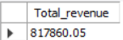

- Average Order Value:
select round(sum(total_price)/count(distinct(order_id)),2) as Avg_order_value from pizza_sales;
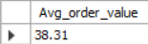

- Total Pizza Sold:
select sum(quantity) Total_pizza_sold from pizza_sales;
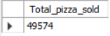

- Total Order Placed:
select count(distinct order_id) Total_orders from pizza_sales;
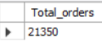

- Average Pizza Per Order:
select round(sum(quantity)/count(distinct order_id),2) as Avg_pizza_per_order from pizza_sales;
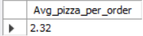

- Daily Trend:

select dayname(order_date) as Day , count(distinct order_id) as No_of_orders from pizza_sales group by dayname(order_date),DAYOFWEEK(order_date) ORDER BY DAYOFWEEK(order_date) ;
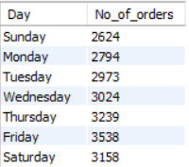
- Hourly Trend:

select hour(order_time) as hour , count(distinct order_id) as No_of_orders from pizza_sales group by hour(order_time) ;

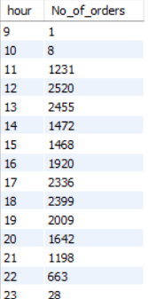

- Percentage of Pizza Sales by category:

select pizza_category, round(sum(total_price)*100/(select sum(total_price) from pizza_sales),2) percentage from pizza_sales group by pizza_category;

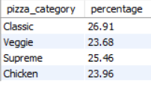

- Percentage of Pizza sales by size :

select pizza_size, round(sum(total_price)*100/(select sum(total_price) from pizza_sales),2) percentage from pizza_sales group by pizza_size order by percentage desc;

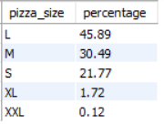

- No. of pizzas sold by Category:

select pizza_category, sum(quantity) as no_of_pizza from pizza_sales group by pizza_category;
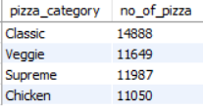

- Top 5 Best Sellers:

select pizza_name, sum(quantity) as Total_Pizzas from pizza_sales group by Pizza_name order by sum(quantity) desc limit 5;

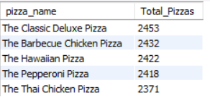

- Top 5 Worst Sellers:

select pizza_name, sum(quantity) as Total_Pizzas from pizza_sales group by Pizza_name order by sum(quantity) limit 5;

